**Event Management system**

# **Project Description :**

The Event Management System is a dynamic web-based platform designed to simplify and automate the management of event halls and related bookings. It supports three primary roles: **Admin, Event Organizer, and User**, each with distinct responsibilities. The Admin holds the highest level of control and logs in using predefined credentials. Once logged in, the Admin can add new categories or locations under which event halls are organized. These event halls are managed by the Admin, who adds their details such as name, capacity, and availability. Another key responsibility of the Admin is to review and verify newly registered organizers, granting them access only after confirming their authenticity. The Admin also handles booking requests for event halls, either approving or rejecting them based on availability and validity. Additionally, the Admin has access to all events, bookings, and user reviews, allowing them to monitor and maintain the quality of services offered through the platform.

**Event Organizers** play the role of event hosts. They begin by registering on the platform and await Admin approval before gaining access to the system. Once verified, they can log in and view available event halls. Organizers can book these halls, publish event details for public visibility, and manage both their current and past bookings. The system offers them the flexibility to cancel bookings if necessary and connect directly with the audience by publishing public events. This increases event reach and visibility. Organizers also have access to event reviews, which help them improve their services.

**Users** must also register and log in to access the platform. Once logged in, they can browse through a list of public events posted by organizers. They can search events based on categories, locations, or organizers, and view detailed information about each event. If interested, users can book tickets, making payments if the event is paid. They can then view their bookings and access their event tickets directly through the system. If they cannot attend an event, they have the option to cancel their bookings before the Event Starts. After attending events, users are encouraged to leave reviews to provide feedback on their experiences.

# **Technologies :-**

The system includes a comprehensive feature set that supports account management, event hall handling, event and ticket booking, reviews, and payment processing. Email notifications ensure that all parties stay informed about actions like approvals, bookings, and cancellations. Additionally, the system can calculate applicable taxes during ticket transactions. Built using Python, Flask, MySQL, HTML, CSS, and Bootstrap, the platform ensures a seamless, secure, and user-friendly experience for all its stakeholders.

# **ER Diagram :-**

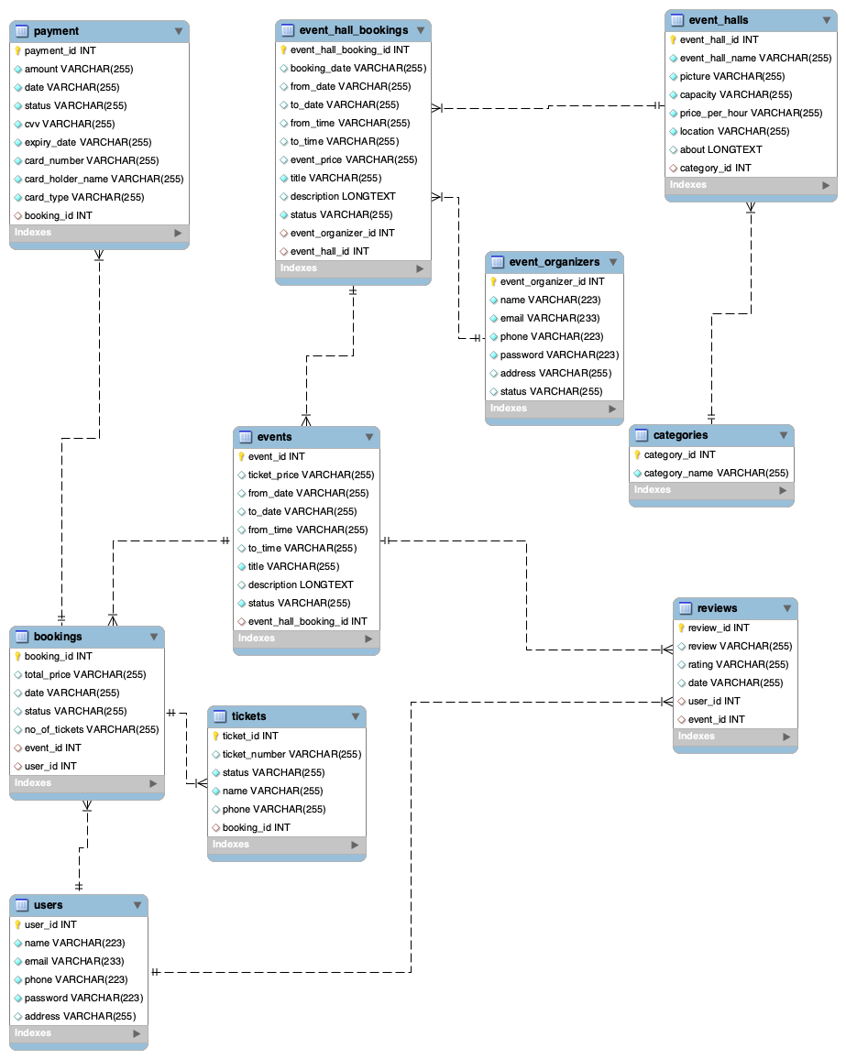

The **Event Management System** database is designed to efficiently handle event hall bookings, event scheduling, payments, and user interactions. It establishes structured relationships between **Admin**, **Event Organizers**, **Users**, and **System Entities** such as events, bookings, tickets, and reviews. Each table is linked through foreign keys to ensure referential integrity and smooth data flow across the system.

At the core of the database are three major user roles - **Admin**, **Event Organizer**, and **User** - who interact with the system’s core entities. The **Admin** manages event halls, categories, and organizer verification. **Event Organizers** create events and book halls, while **Users** browse events, make bookings, purchase tickets, and provide Reviews.

## **Firstly we create the database like this and here we have 10 tables :**

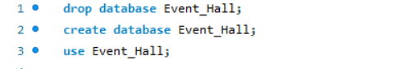

### **1. Categories**

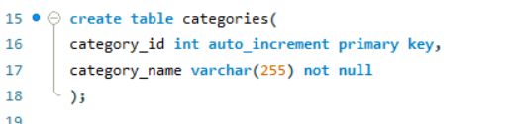

* **Purpose:** Stores the different event categories (e.g., Wedding, Conference, Party).
* **Primary Key:** category_id
* **Relationship:** Connected to event_halls table, categorizing halls under specific event types.

### **2. Event_halls**

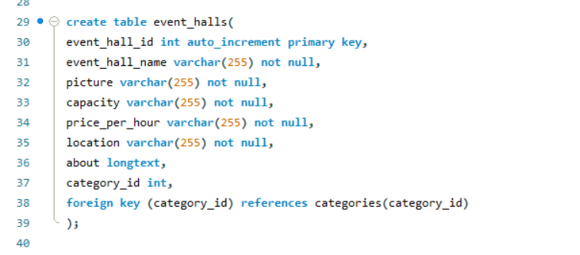

* **Purpose:** Contains details of each hall available for events.
* **Attributes:** Hall name, picture, capacity, location, description.
* **Primary Key:** event_hall_id
* **Foreign Key:** category_id (links each hall to its category).
* **Relationship:** Linked with event_hall_bookings for managing hall reservations.

### **3. Event_hall_bookings**

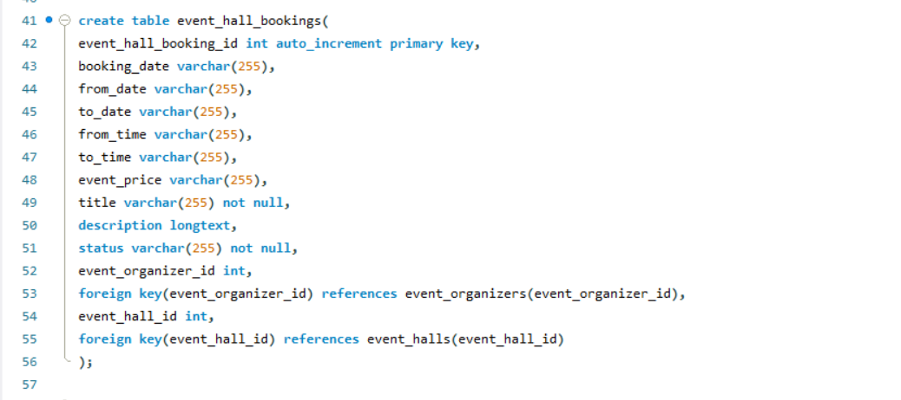

* **Purpose:** Records the hall booking details made by event organizers.
* **Primary Key:** event_hall_booking_id
* **Foreign Keys:**
  + event_hall_id : from event_halls
  + event_organizer_id : from event_organizers
* **Attributes:** Booking date, duration, description, and status.
* **Relationship:** Connected to events to associate specific events with booked halls.

### **4. Event_organizers**

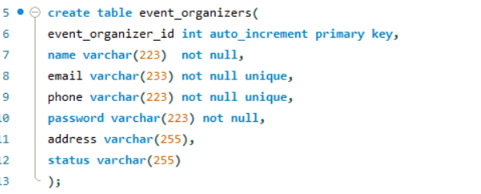

* **Purpose:** Manages registered organizers who create and host events.
* **Primary Key:** event_organizer_id
* **Attributes:** Name, email, phone, password, address, and verification status.
* **Relationship:**
  + Linked to event_hall_bookings for booking halls.
  + Linked to events for creating and managing event details.

### **5. Events**

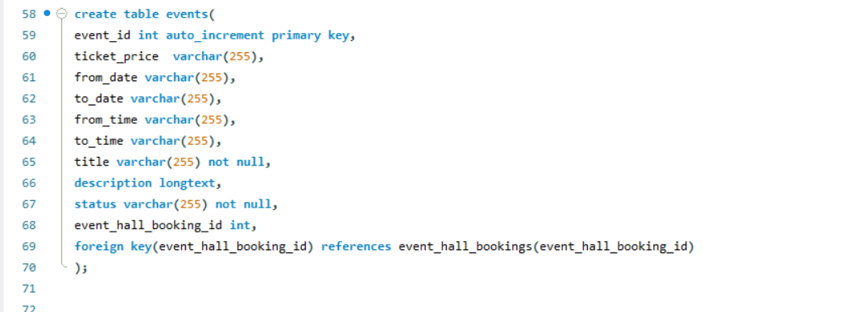

* **Purpose:** Contains all event-related details like name, date, time, price, and description.
* **Primary Key:** event_id
* **Foreign Key:**
  + event_hall_booking_id : connects to event_hall_bookings
* **Relationship:**
  + Linked to bookings and reviews for tracking participation and feedback.

### **6. Users**

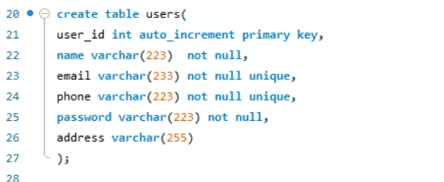

* **Purpose:** Represents registered users who can book tickets and attend events.
* **Primary Key:** user_id
* **Attributes:** Name, email, phone, password.
* **Relationship:**
  + Linked to bookings (user event reservations).
  + Linked to reviews (event feedback submission).

### **7. Bookings**

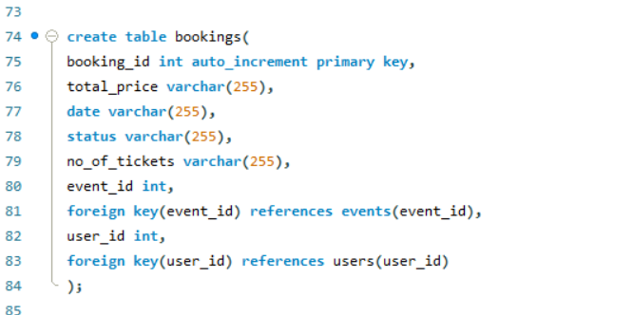

* **Purpose:** Manages event bookings made by users.
* **Primary Key:** booking_id
* **Foreign Keys:**
  + user_id : from users
  + event_id : from events
* **Attributes:** Ticket price, total tickets, booking status.
* **Relationship:**
  + Connected to tickets for generating physical or digital entry passes.
  + Linked to payment for payment tracking.

### **8. Tickets**

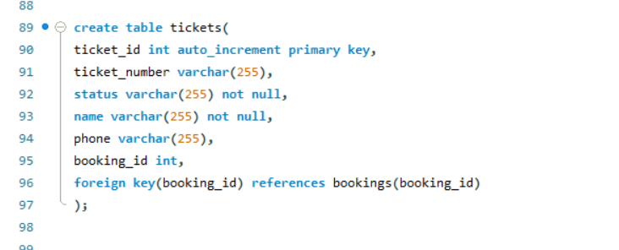

* **Purpose:** Stores ticket details for each user’s booking.
* **Primary Key:** ticket_id
* **Foreign Key:** booking_id : from bookings
* **Attributes:** Ticket number, status, user contact info.
* **Relationship:** Each ticket belongs to a booking made by a specific user.

### **9. Payment**

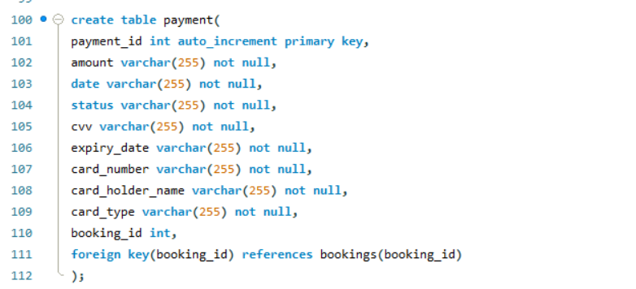

* **Purpose:** Handles payment details for event bookings.
* **Primary Key:** payment_id
* **Foreign Key:** booking_id : from bookings
* **Attributes:** Amount, payment date, card details, and payment status.
* **Relationship:** Each payment record is linked to a specific booking for tracking financial transactions.

### **10. Reviews**

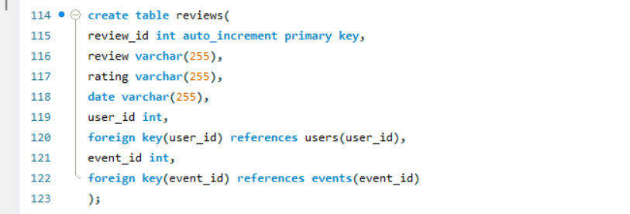

* **Purpose:** Stores user feedback and ratings for attended events.
* **Primary Key:** review_id
* **Foreign Keys:**
  + event_id : from events
  + user_id : from users
* **Attributes:** Review text, rating, and date.
* **Relationship:** Helps improve event quality and provides insights for organizers.

## Sample snippets :

### **1. Categories**

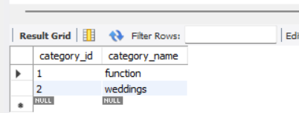

### **2. Event_halls**

### **3. Event_hall_bookings**

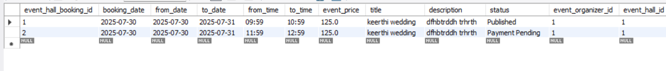

### **4. Event_organizers**

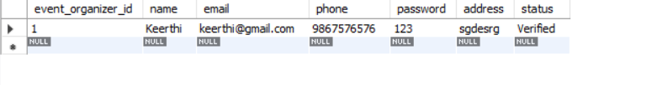

### **5. Events**

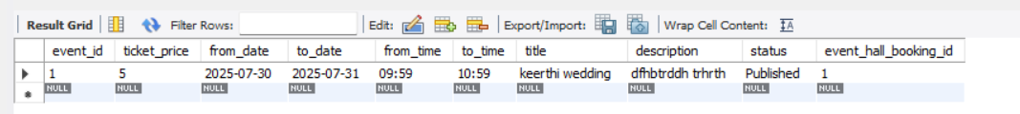

### **6. Users**

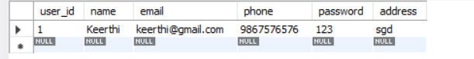

### **7. Bookings**

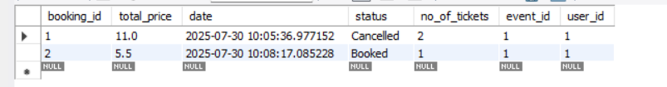

### **8. Tickets**

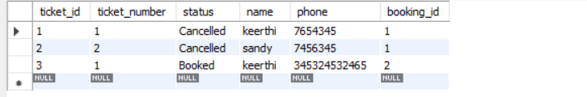

### **9. Payment**

### 

### **10. Reviews**

### 

# **Functionalities :-**

## **Admin :**

* Login
* View & Verify Event Organizer
* Add & View Categories
* Add & View Event Halls
* View & Accept or Reject Event Hall Bookings
* View Event Bookings
* View Tickets
* View Reviews
* View Payments
* Logout

## **Event organizer:**

* Register
* Login
* Book Event Hall
* Publish Event
* View Event Bookings
* View Tickets
* View Reviews
* View Payments
* Logout

**User :**

* Register
* Login
* View Past Event
* View Ongoing Events
* Search Events
* Book Tickets
* Cancel Bookings
* View Payments
* Give Review Ratings
* Logout

# **UML Diagrams :-**

## **Use case Diagrams :**

Admin

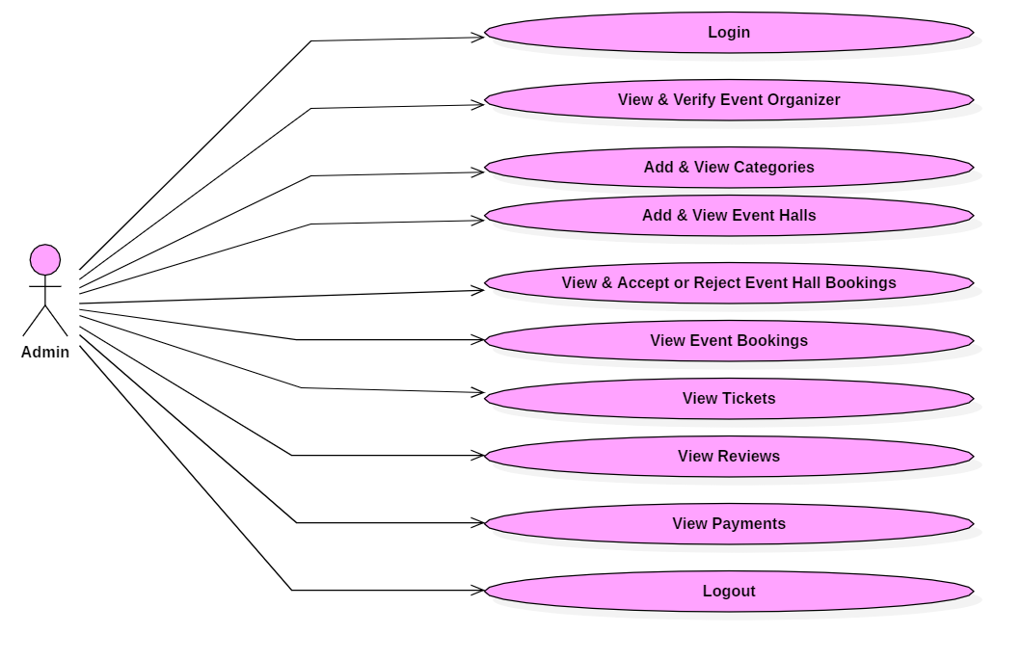

Event Organizer :

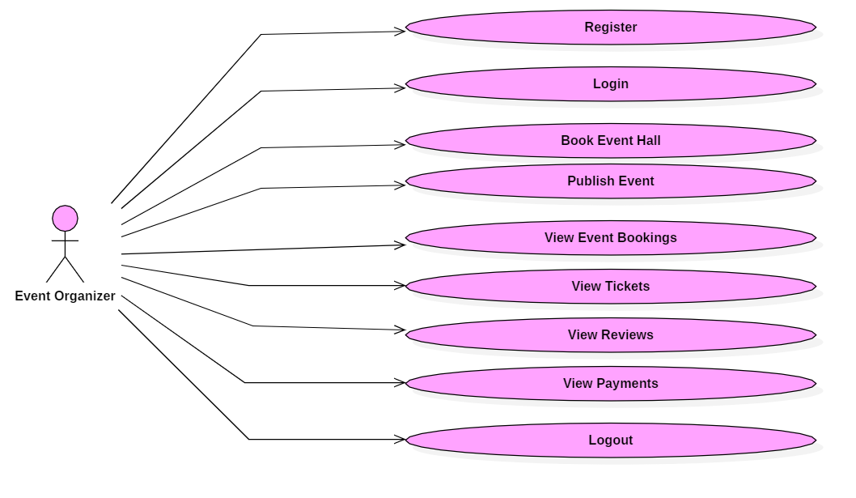

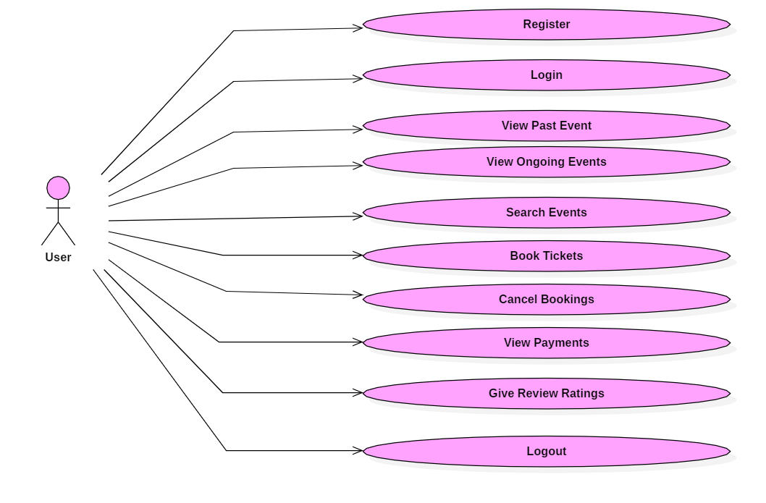

## **Class Diagram :**

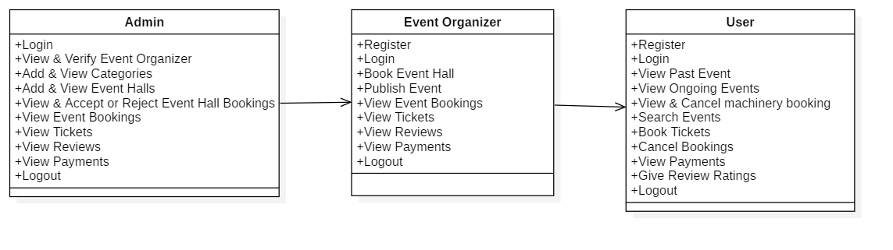

## **Sequence Diagram :**

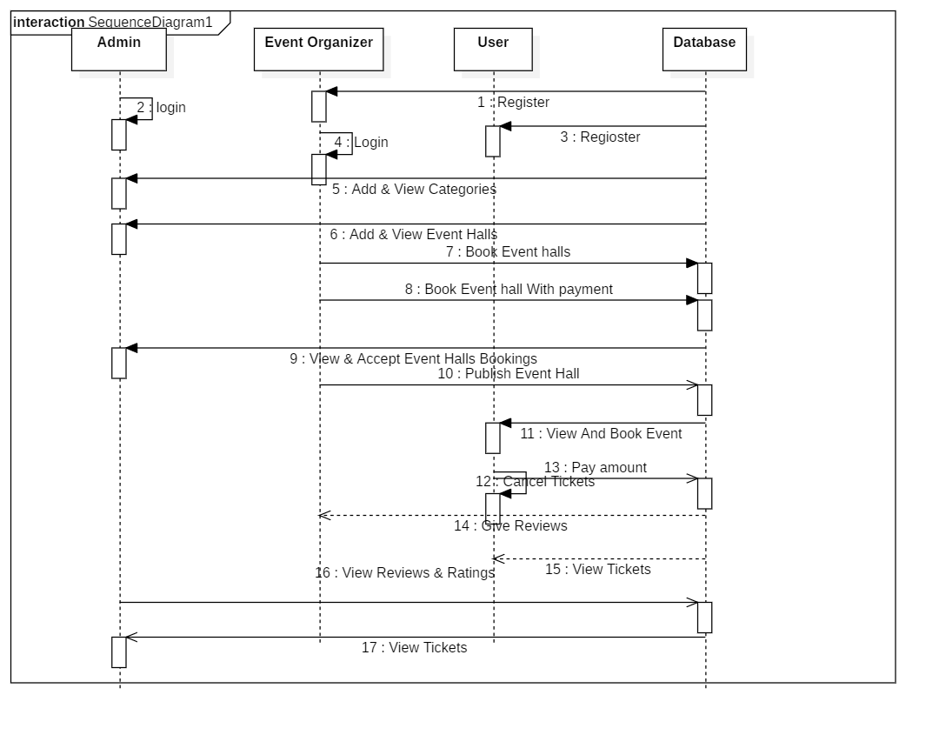

## 

## **Architecture Diagram :**

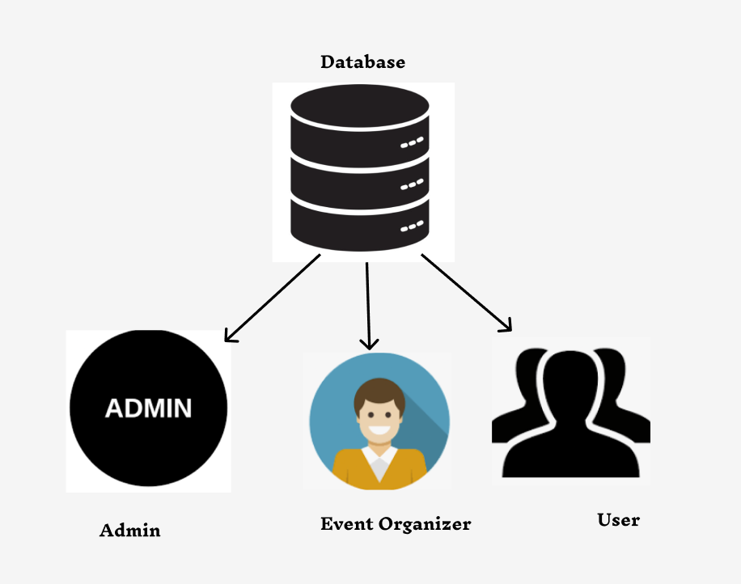

# **Website Screen Shorts Pages :**

## **Home Page:**

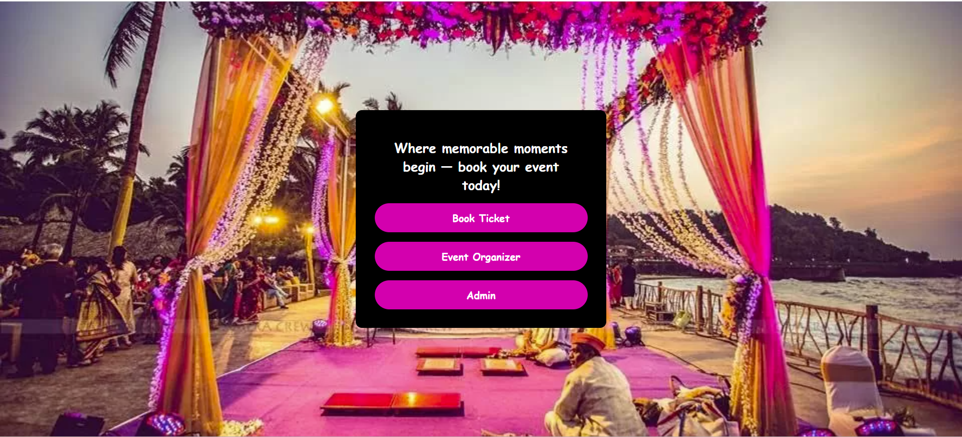

This is the main home for this website.

## **Admin login page:**

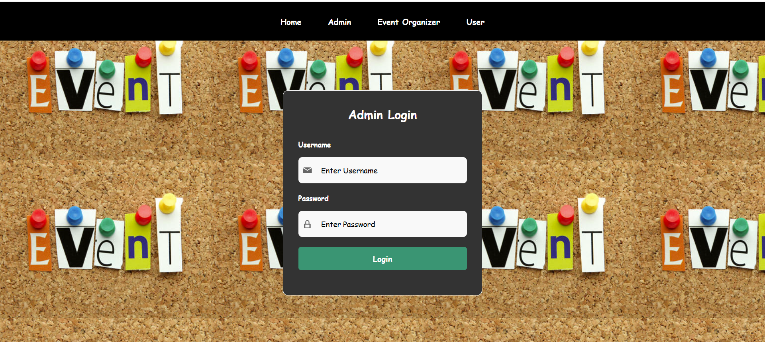

This is the admin login page. In this the admin will login into the website with their predefined login credentials like username and password by clicking the login button and the page will be redirected into the admin home page.

**Admin Home Page :**

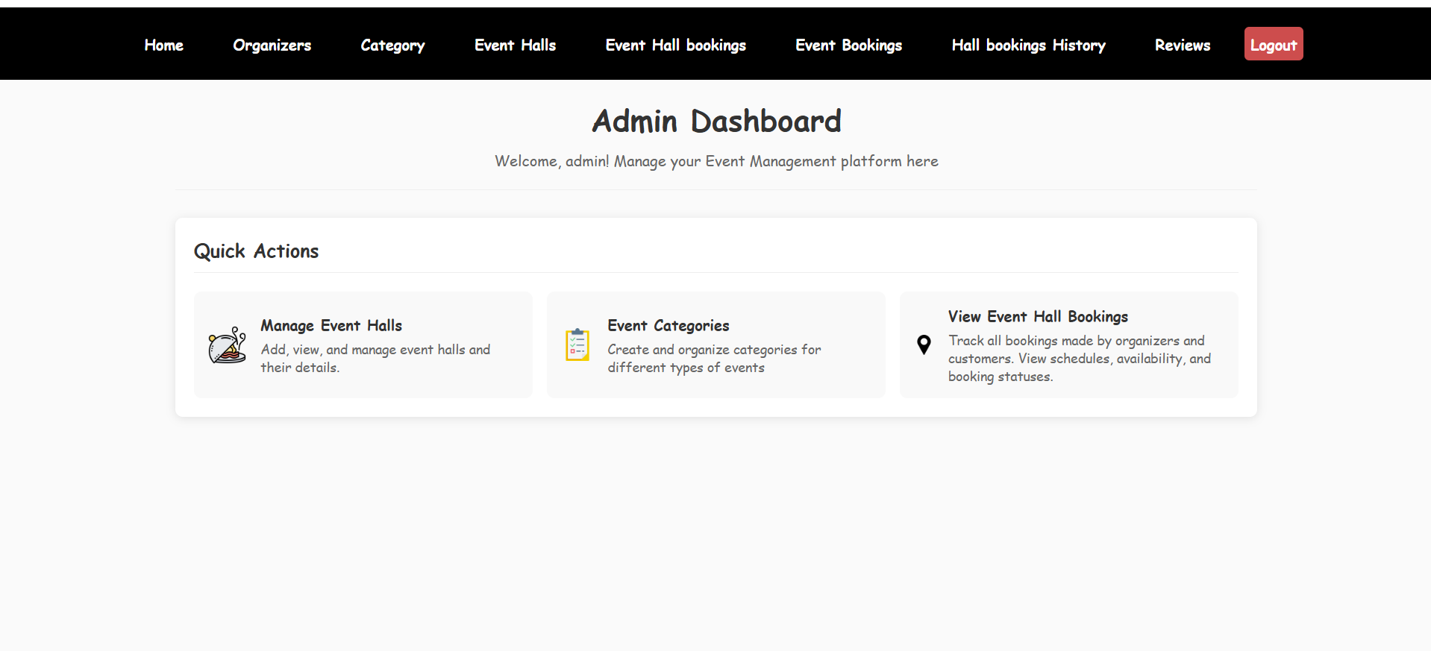

This is the admin home page.

## **Event Organizer Registration Page:**

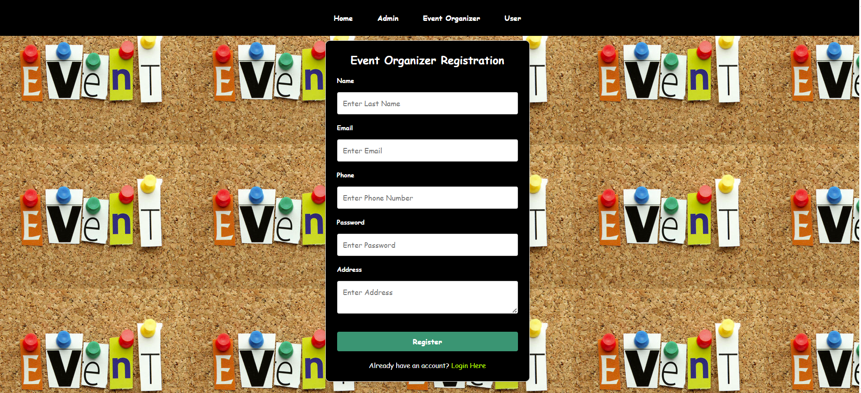

This is the event organizer registration page. In this The event organizer will register into the website by giving all above information and clicking the register Button.

## **Event Organizer Login Page:**

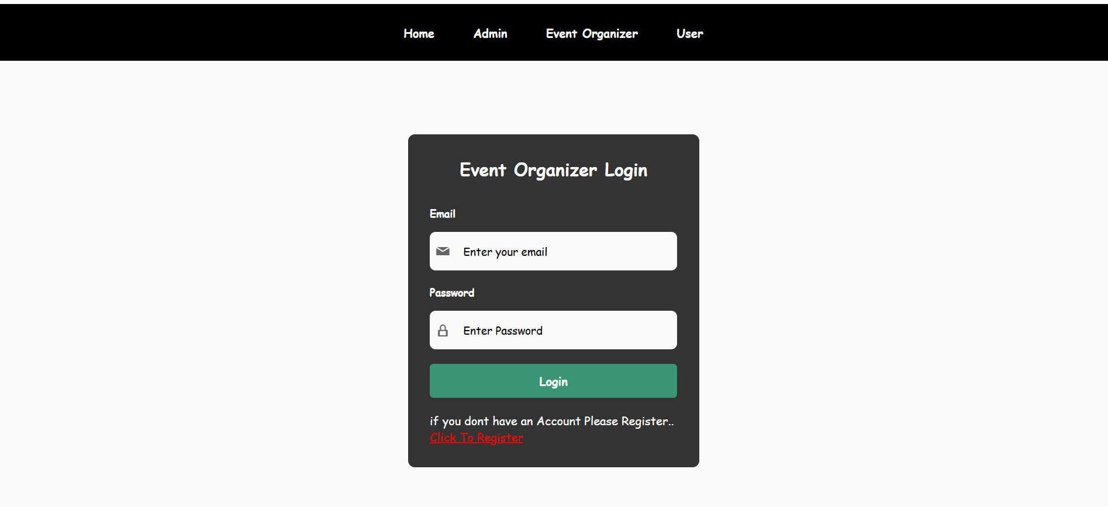

This is the event organizer Login Page. They begin by registering on the platform and await Admin approval before gaining access to the system. Once verified, they can log with a registered email and password by clicking the login button.

**Admin view & Verify Event Organizer :**

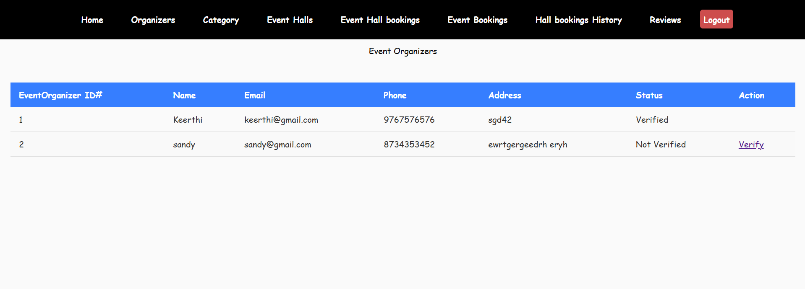

The admin can view and verify the list of event organizers into this page by clicking the verify button.

**Admin Add & View & Edit Categories :**

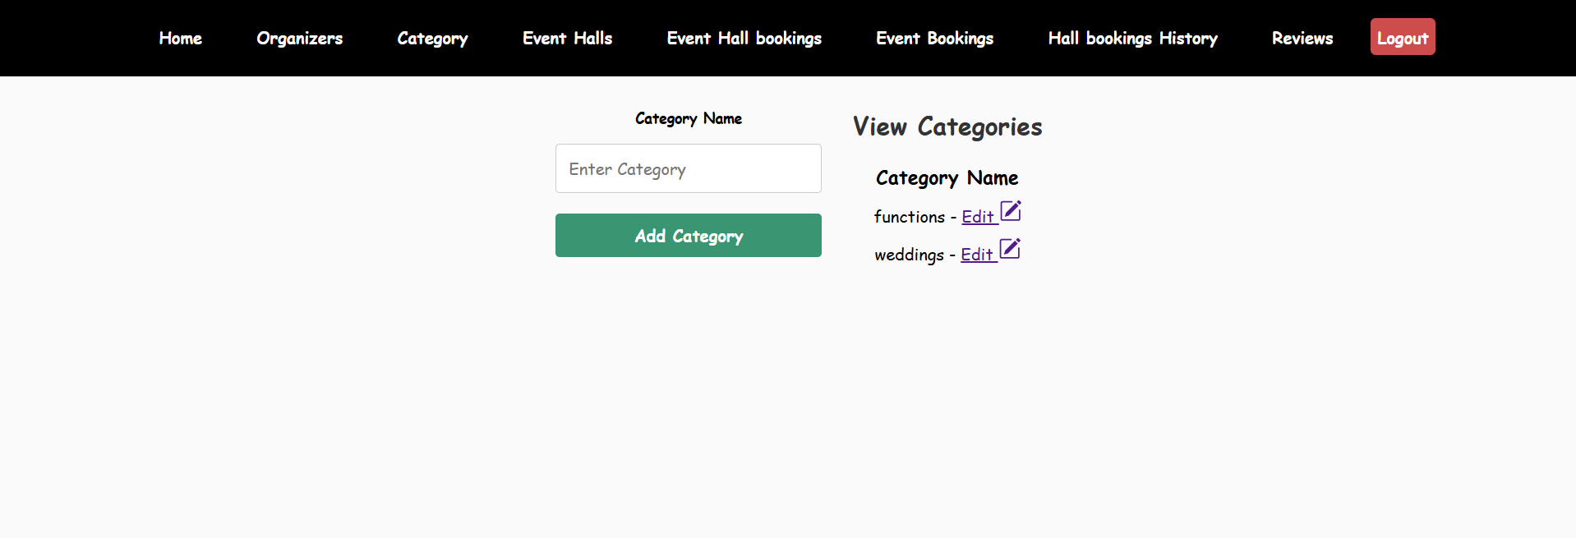

In this page the admin can add the category by entering category name and by clicking on the add category button . and also the admin can view the list of added categories into the same page.

**Admin Add & view Event Halls :**

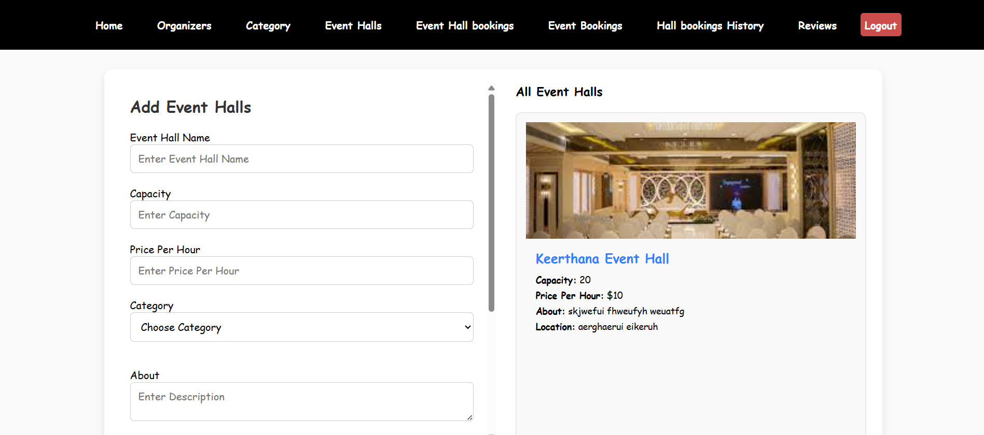

In this page the admin can add the Event Halls by entering the above information and by clicking on the add Event hall button . And also the admin can view the list of added event halls into the same page.

Event Organizer Home :

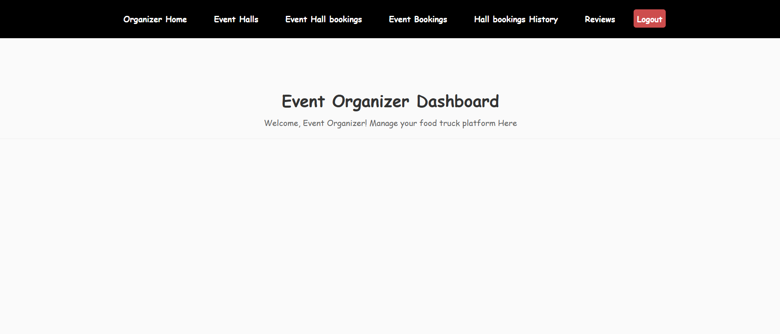

This is the vent organiser Home page

**Event Organizer View & Book Event Hall :**

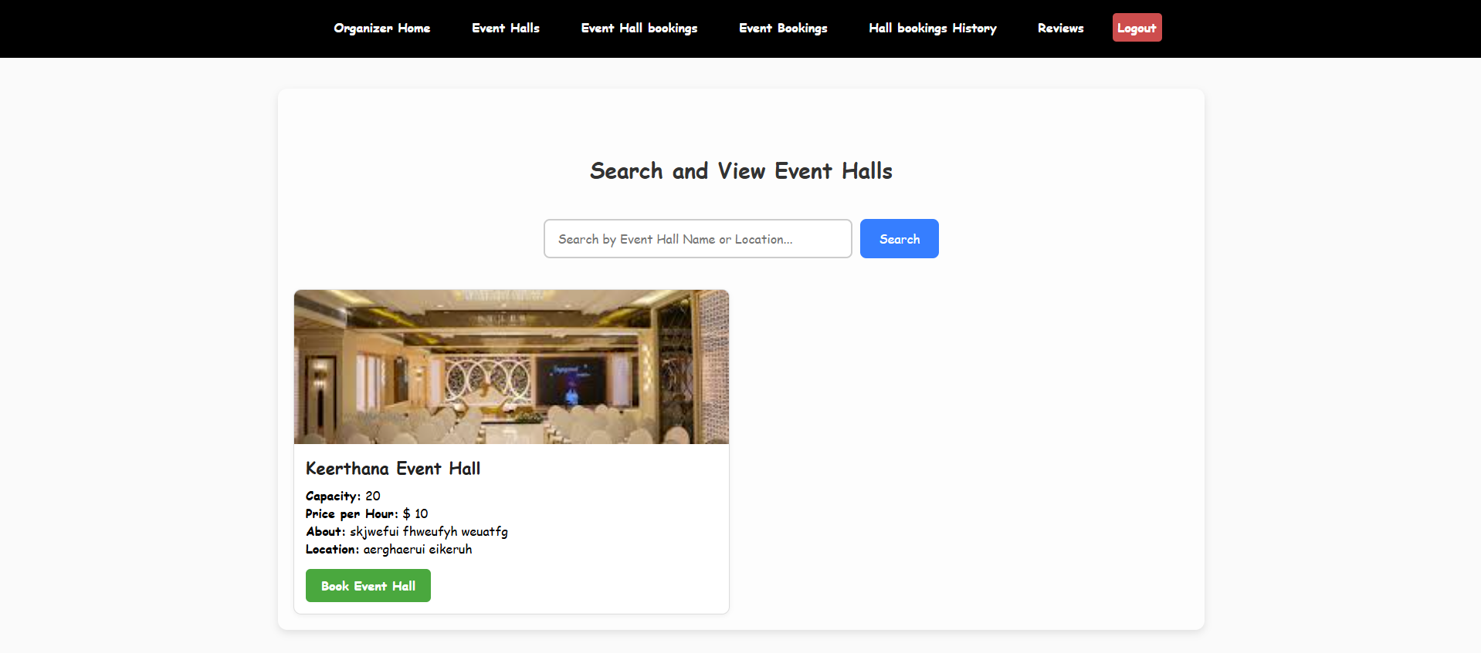

In this the event organiser can search and view a list of event halls. If the Event organizer wants to book the event hall, they can click the book event hall button and the page will be redirected into the bookings page.

**Book Event Hall :**

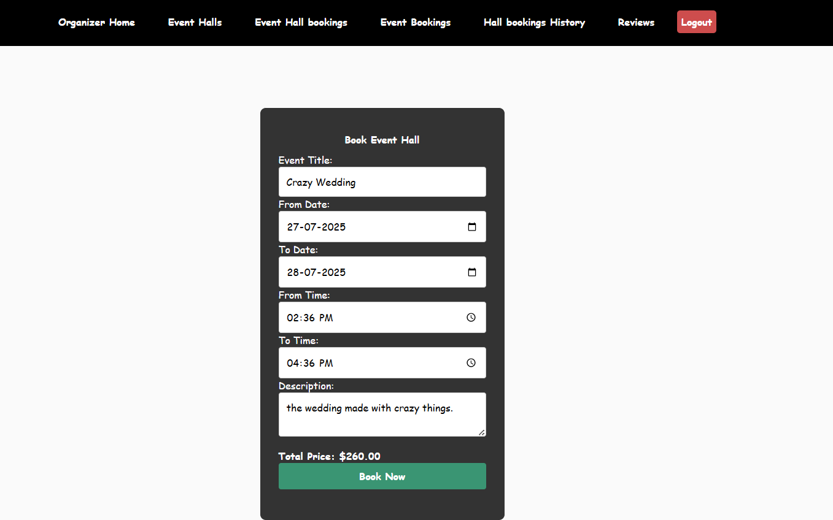

In this the event organizer can fill in all the details and the total price can be calculated automatically by the price per hours and days and then by clicking the book event hall button the page will be redirected into the transaction page.

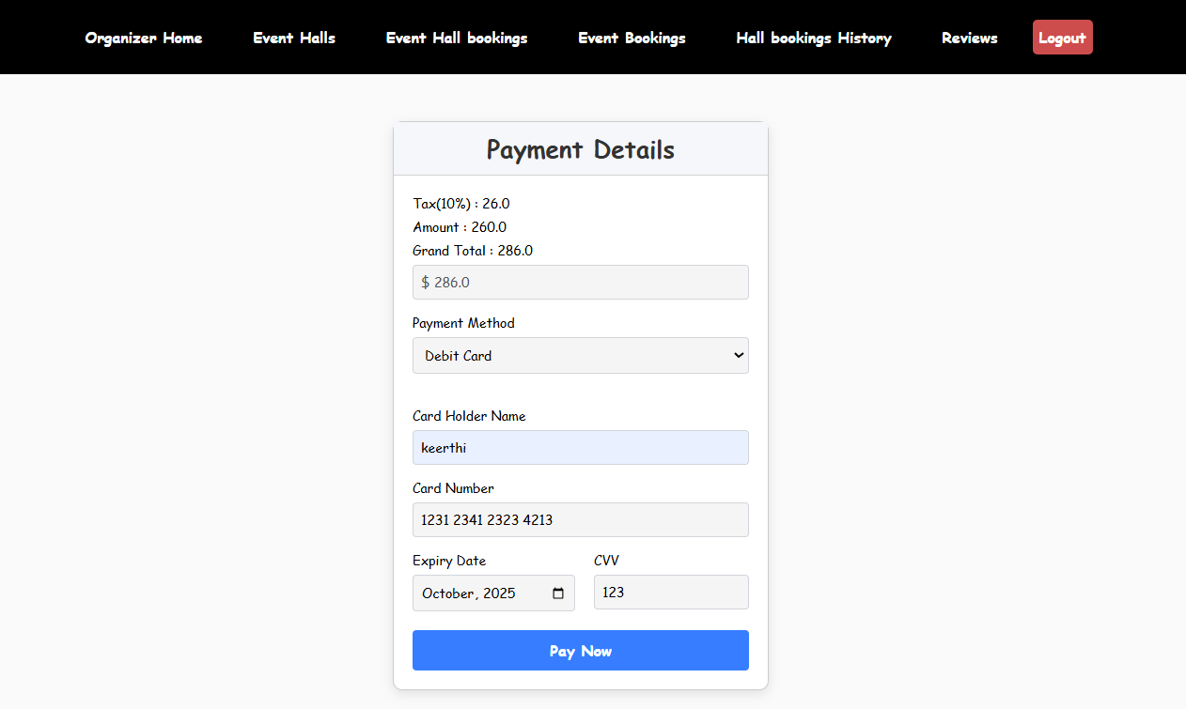

In this the event organizer can fill in all the details and pay the total amount by clicking the payment button the event hall will be booked.

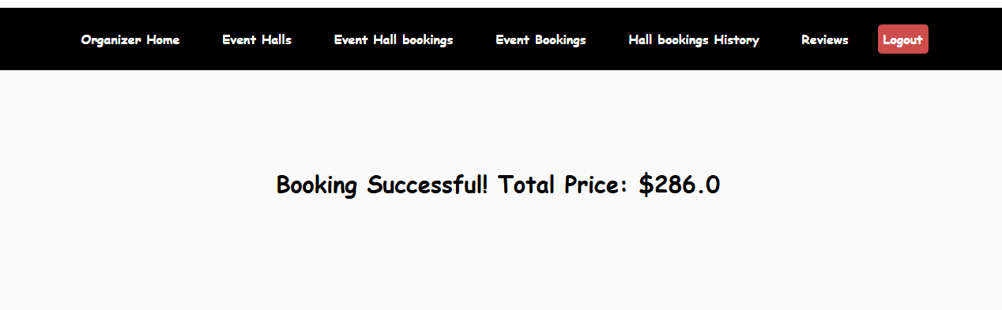

**Event organizer View Bookings :**

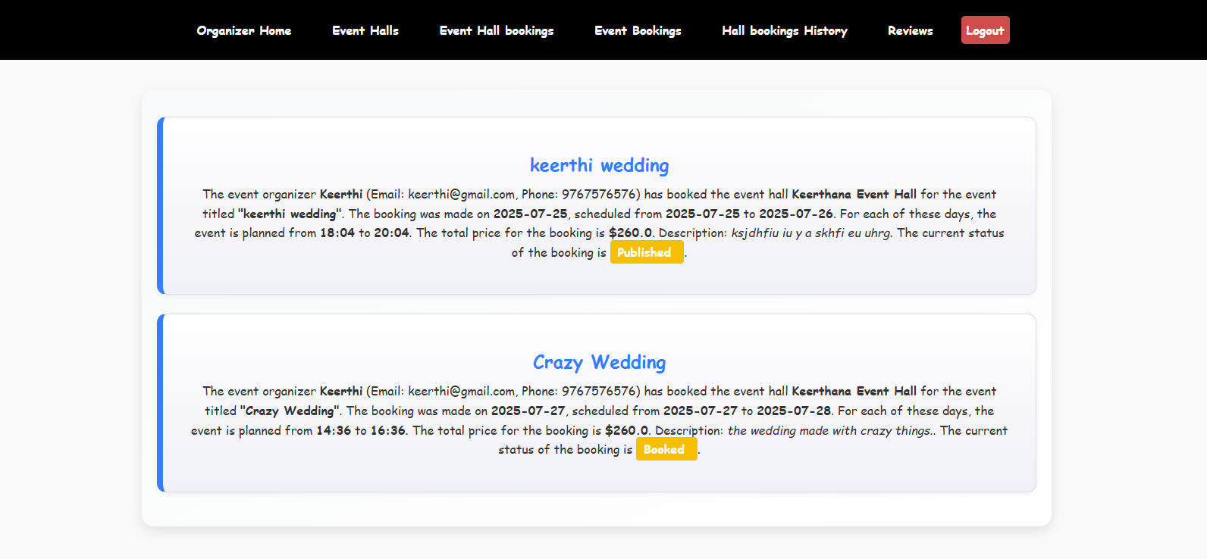

The event organizer can view the event hall bookings into this page and the status will be booked.

**Admin View Bookings :**

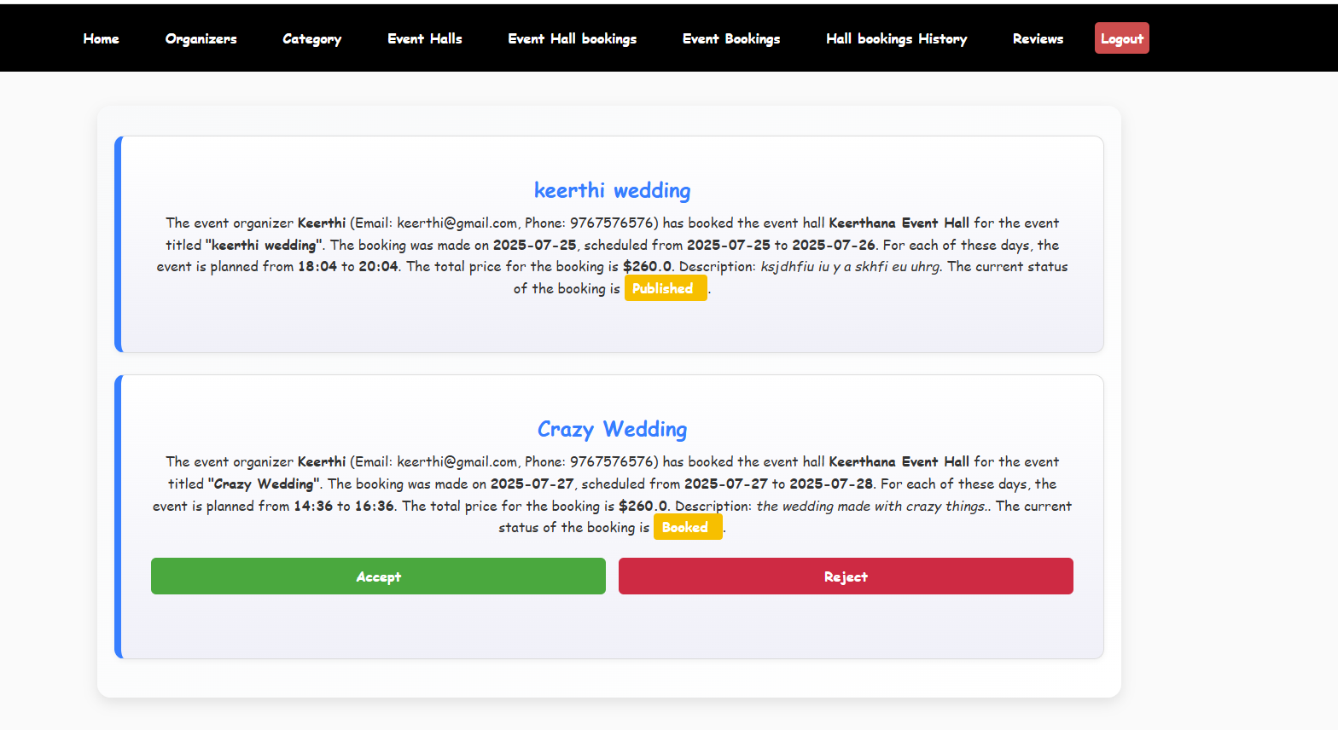

The admin can view and accept or reject the event hall bookings into this page. If the admin clicks the accept button the status will be updated as Accepted , otherwise if you click the reject button the status will be updated as rejected..

**Event Organizer Publish Event :**

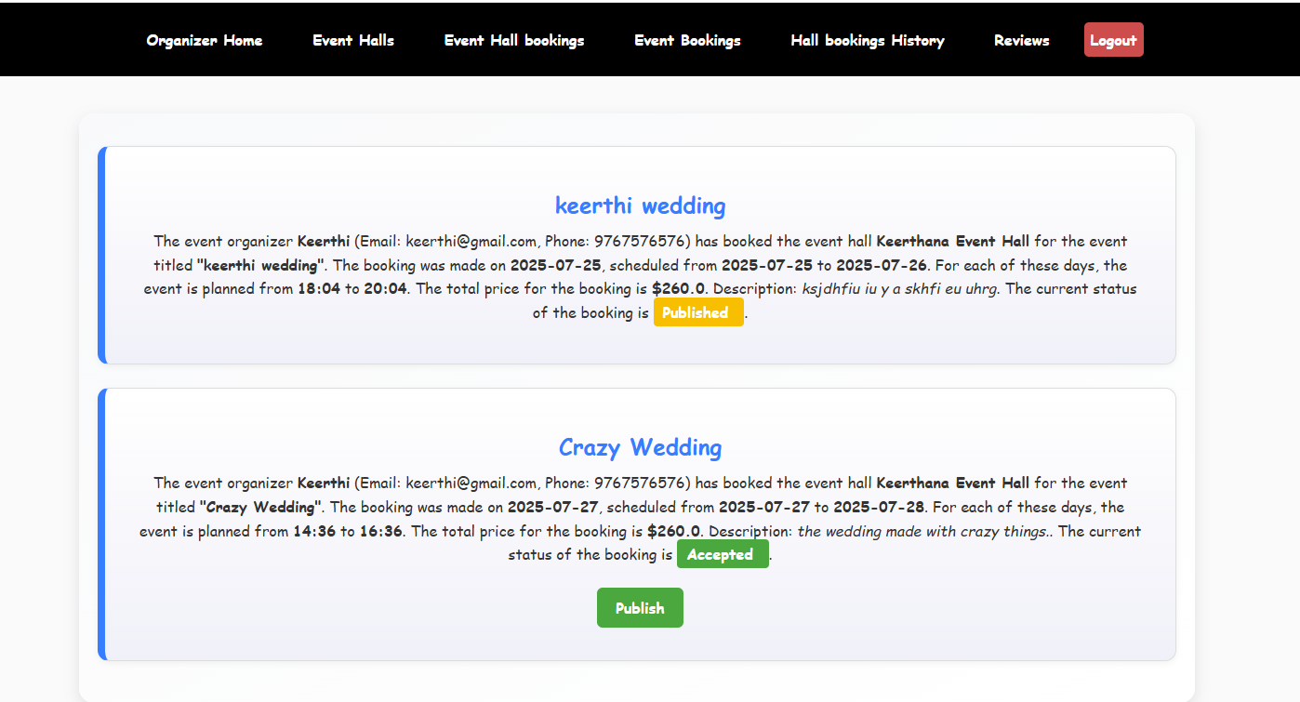

The event organizer can view the booking status. They can publish the event after the admin accepts the booking. By clicking the Publish button the event will be published.

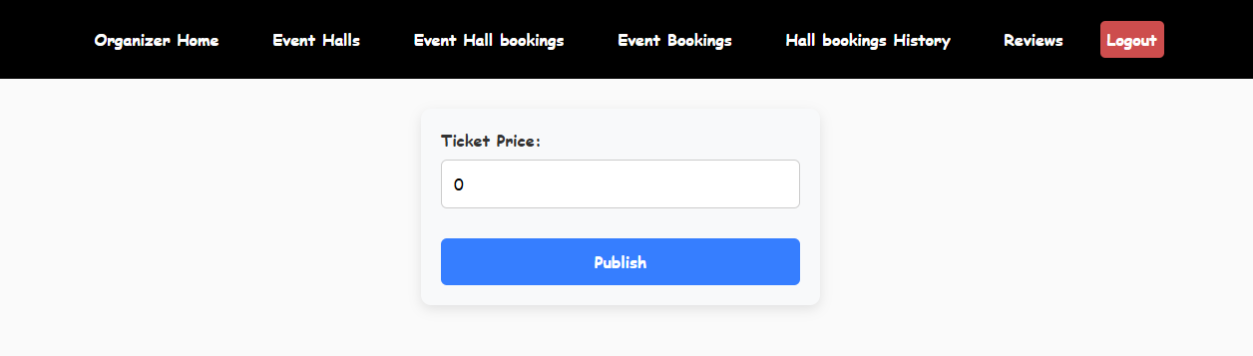

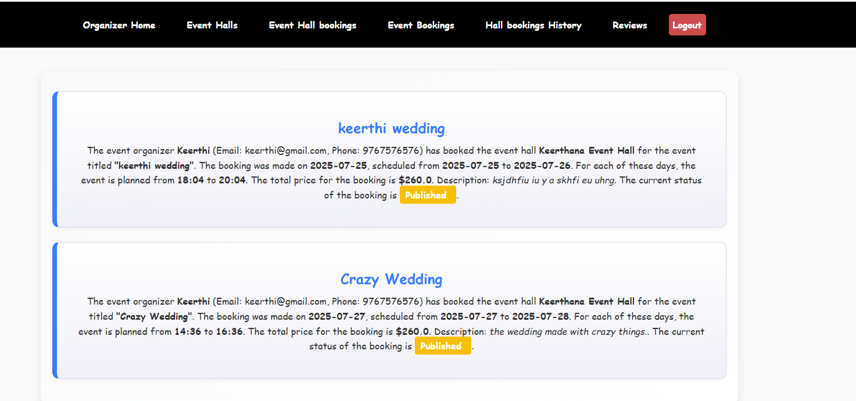

## **User Registration Page:**

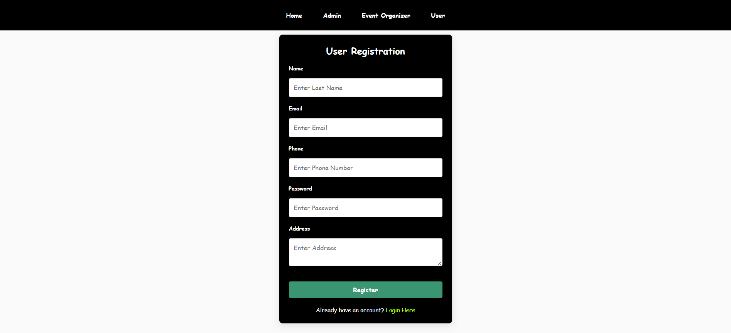

This is the User registration page. In this The user will register into the website by giving all above information and clicking the register Button.

## **User login page:**

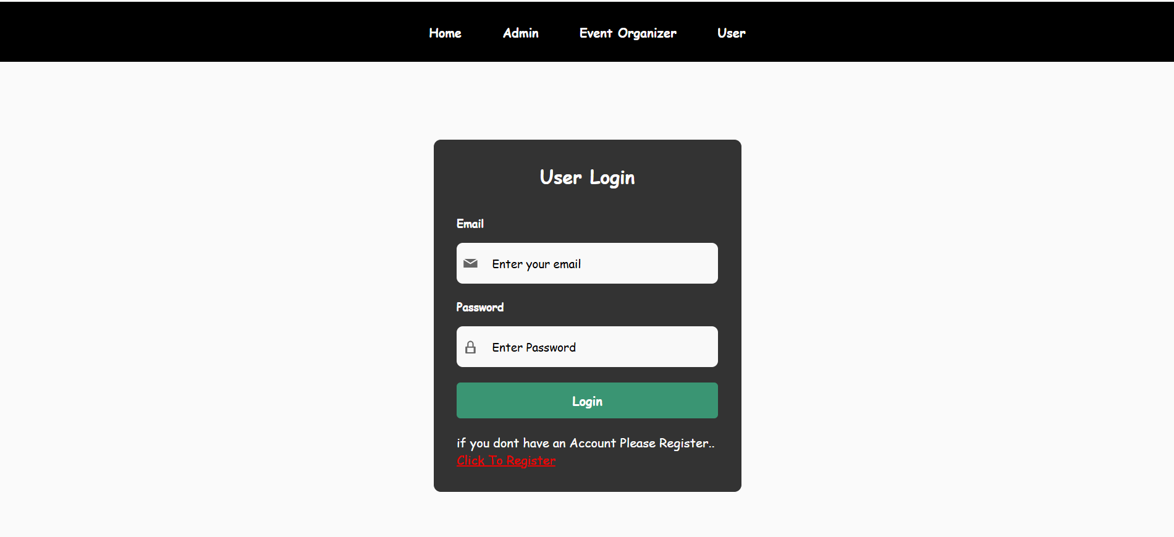

This is the user login page. The user can login into the website by entering registered email and password and clicking the login button the user will be logged.

**Customer View Ongoing Events :**

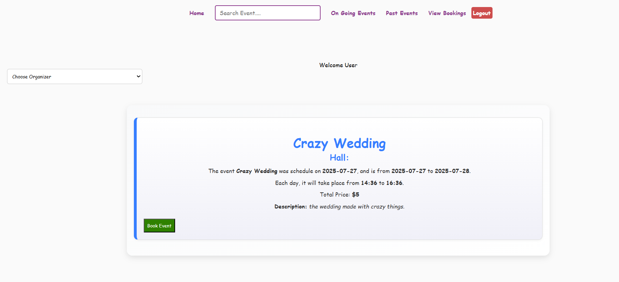

In this page the user can view the ongoing events. If the user wants to book the event ticket then they can book the event by clicking on the book Event button and the page will be redirected into the book tickets page.

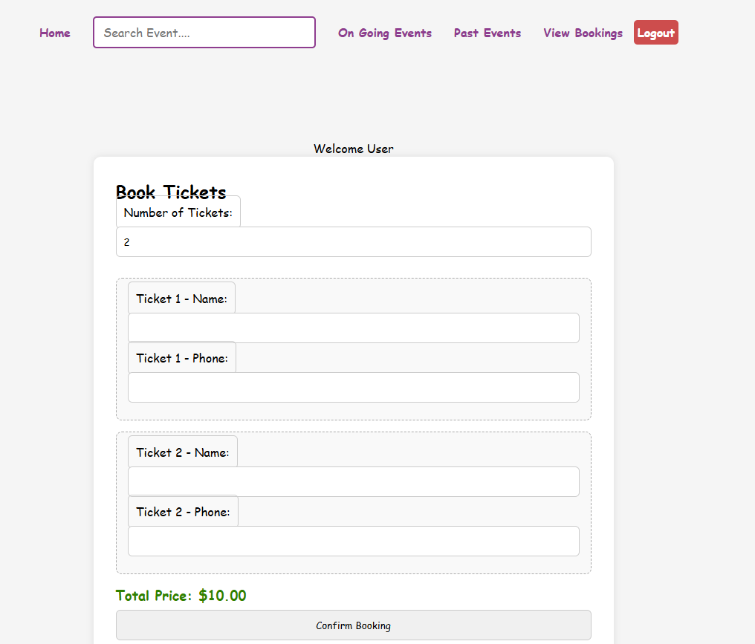

The user can book the tickets by entering the number of tickets and giving the name and phone number and clicking on the confirm booking button the page will be redirected into the payment page.

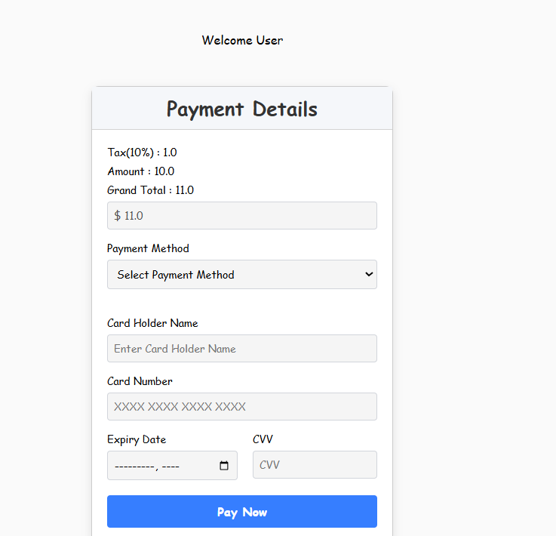

By entering all above details and by clicking on the pay now button the tickets will be booked.

**User View Past Events :**

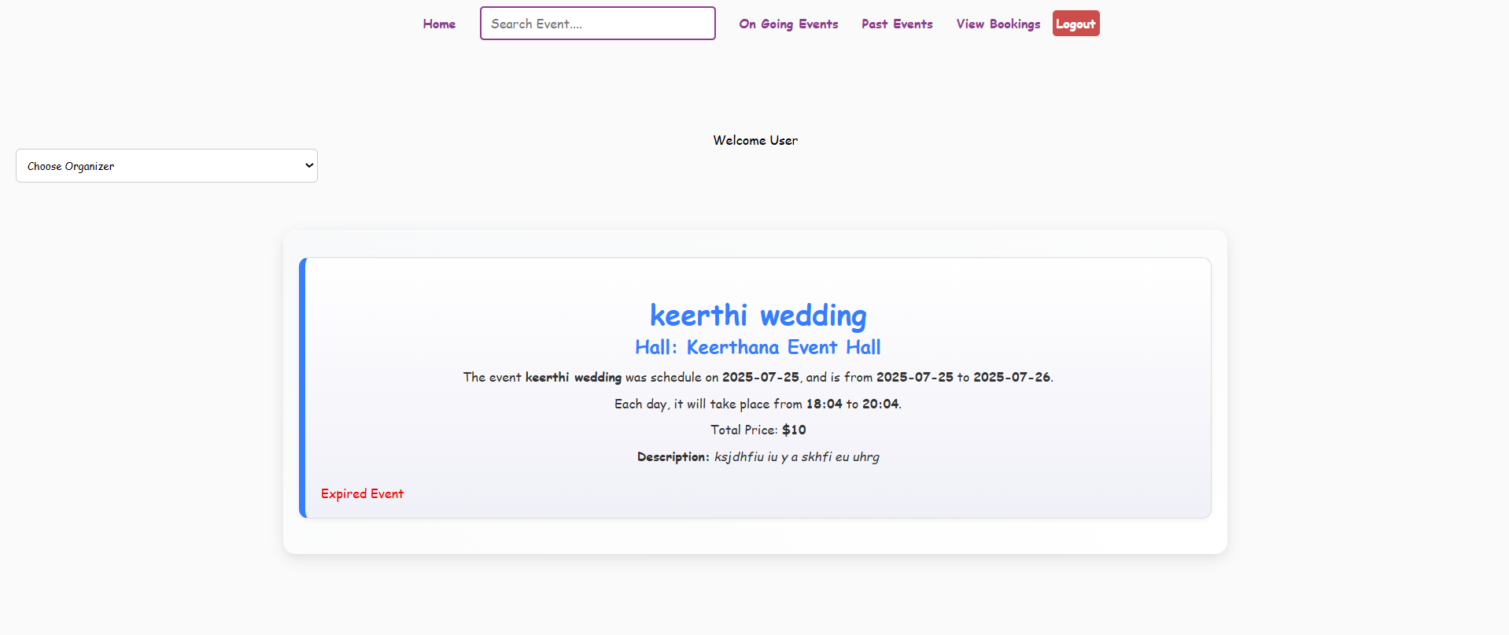

**User View Bookings :** 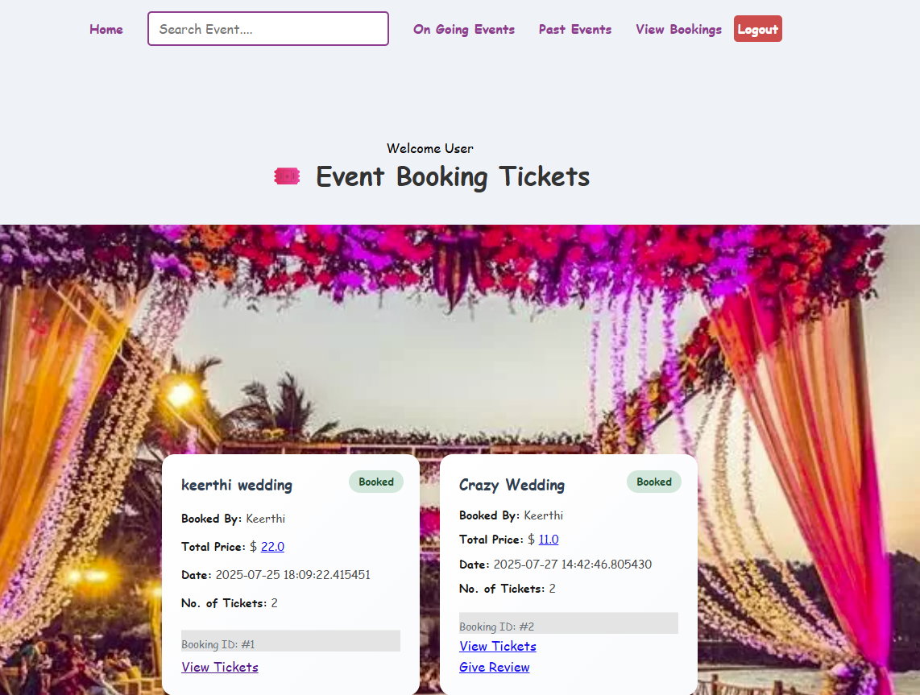

The user can view the event bookings into this page.

**View Tickets :**

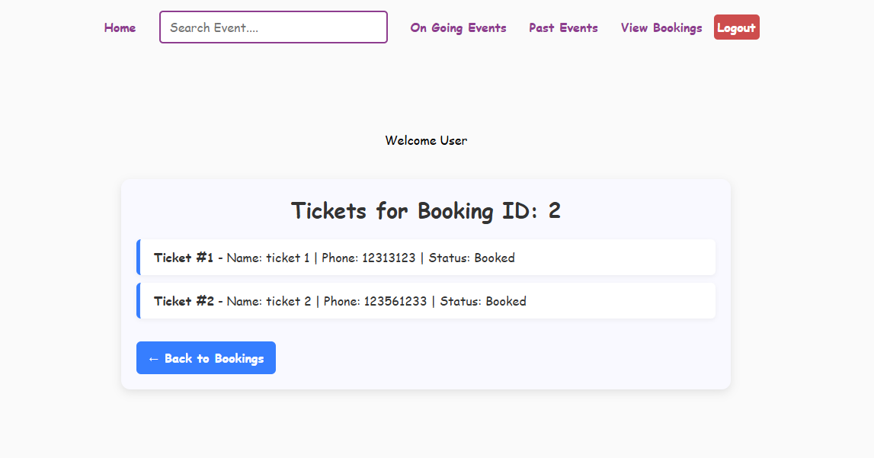

**Give review ratings :** 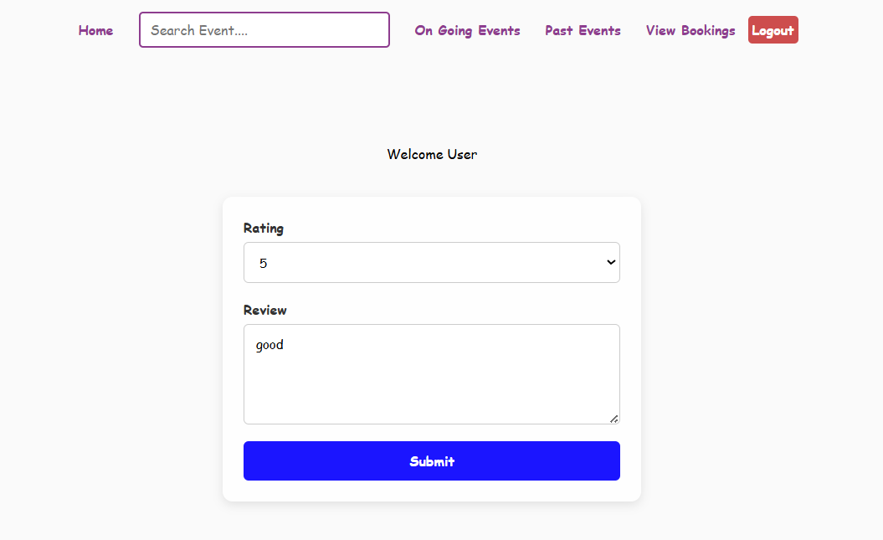

**Event Organizer View Event Reviews :**

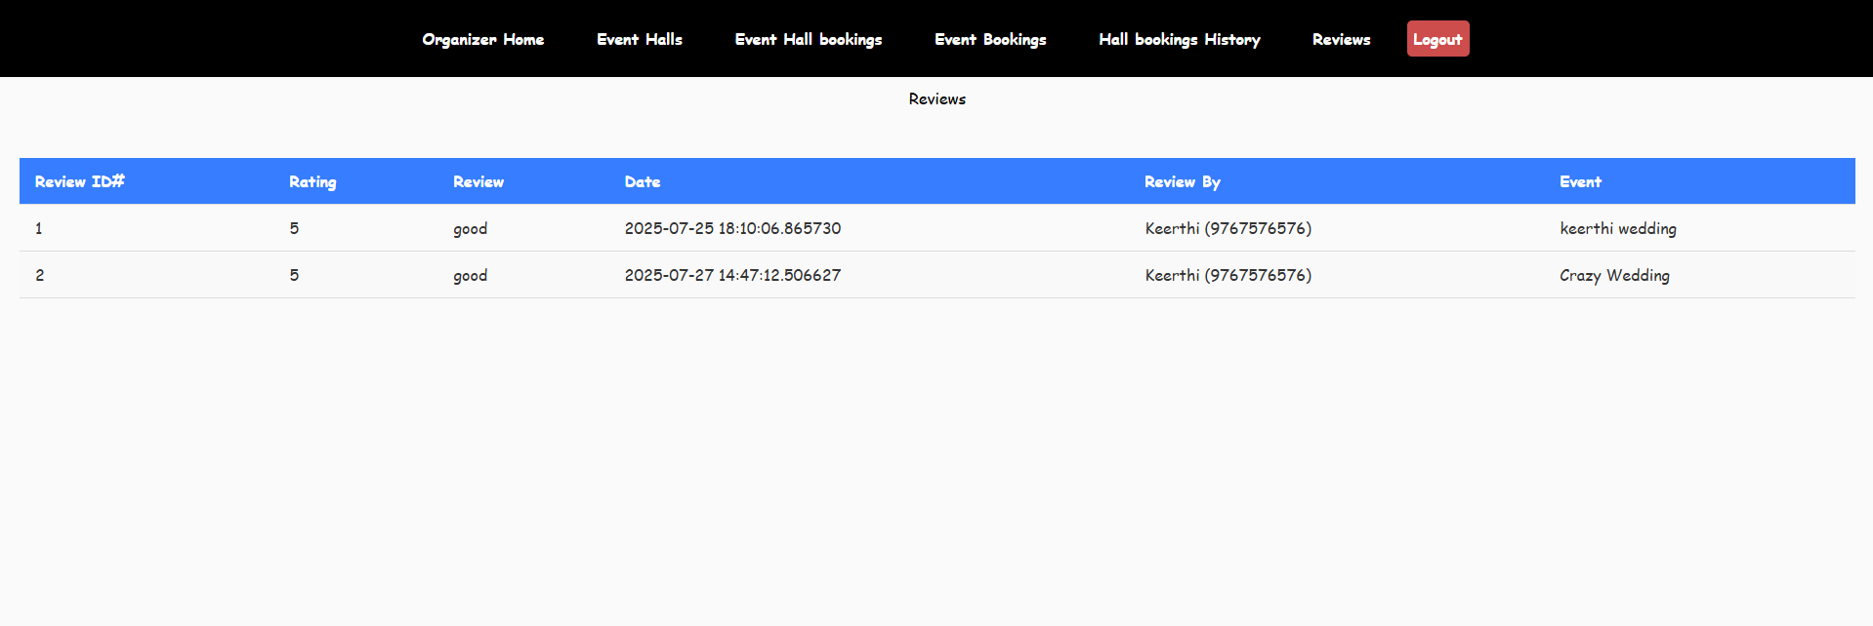

**View Transaction :** 